**Name:Gaurav Kishor Patil**

**Roll No:54 Batch:C**

**Div:2**

|  |
| --- |
| Experiment No. 5 |
| Code conversion |
| Date of Performance:23/08/23 |
| Date of Submission:06/09/23 |

**Aim** - To implement 4-bit Binary to Gray and Gray to binary code converter.

**Objective -**

1. To understand the function of Code Converters
2. Understand how to implement Binary to Gray and Gray to Binary code Converters using logic gates.

**Components required:**

1. IC’s - 7486(EX-OR), 7408(AND)
2. Bread Board
3. Connecting wires.

**Theory:**

To convert a binary number to corresponding Gray code, the following rules are

applied

1. The MSB in the Gray code is the same as the corresponding bit in a binary number.
2. Going from left to right, add each adjacent pair of binary digits to get the next Gray codedigit. Disregard carries.

As the first step to design a binary to Gray code Converter, set up a truth table with binary numbers B3B2B1B0 and corresponding gray code numbers G3G2G1G0. set up a circuitrealizing the simplified logic expressions obtained using K maps for Gs as the functions of Bs.

To convert from Gray code to binary, the following rules are applied.

1. The most significant digit in the binary number is the same as the corresponding digit in the Gray code
2. Add each binary digit generated to the Gray code digit in the next adjacent position. Disregard carries.

To design the Gray to Binary code converter, set up the truth table and get simplified expressions using Karnaugh maps for each binary bits as a function of Gray code bits. Each Gray code number differs from the preceding number by a single bit.

**Circuit Diagram and Truth Table** -

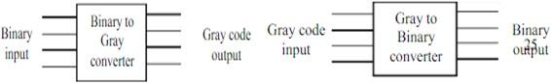

**Binary to Gray Code Converter -**

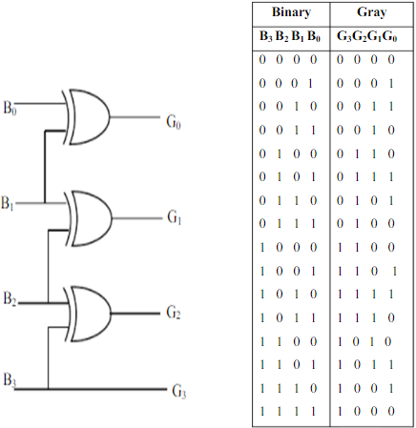

**Gray to Binary Code Converter -**

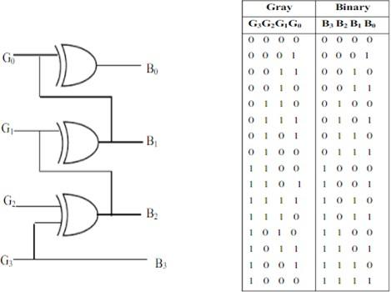

**Procedure -**

1. Test all the components and IC packages using multimeter and digital IC tester.
2. Make the connections as per the circuit diagram.
3. Switch on VCC and apply various combinations of input according to truth table.
4. Note down the output readings for different combinations of inputs and verify truth tables.

Program

Output

**Conclusion -**

Code converters are digital circuits that convert one type of binary code to another. The most commonly used codes are binary, Gray, excess-3, and BCD. Logic gates such as AND, OR, and NOT gates can be used to implement code converters. For example, a binary to Gray code converter can be implemented using Karnaugh maps to obtain the minimized Boolean expressions for each output bit. These expressions can then be implemented using a combination of AND, OR, and NOT gates. Similarly, a Gray to binary code converter can be implemented using Karnaugh maps to obtain the minimized Boolean expressions for each output bit. These expressions can then be implemented using a combination of AND, OR, and NOT gates. Reversible logic gates can also be used to implement code converters in a more efficient manner